Practical Guide Regarding the Order to Disclose Identification Information of the Sender
The 9th Civil Division
Tokyo District Court

※ This Guide describes the practice of the Division as of April 1st, 2023, which may be amended depending on the circumstances.

※ Abbreviations
“the Act” Act on the Limitation of Liability for Damages of Specified Telecommunications Service Providers and the Right to Demand Disclosure of Identification Information of the Sender (after the amendment of 2021)
“the Rules” Rules on the Limitation of Liability for Damages of Specified Telecommunications Service Providers and the Right to Demand Disclosure of Identification Information of the Sender

1. Backgrounds
A person alleging that their rights are violated by information disseminated on the internet by an anonymous sender may file the Petition for the Order to Disclose Identification Information of the Sender (hereinafter referred to as “the Disclosure Order”) as a “non-contentious case”, subject to certain requirements, against related content providers (CP) and internet service providers (ISP).
The Petitioner may also file the Petition for the Order of Provision (hereinafter referred to as “Provision Order”) and the Order of Prohibiting Deletion (hereinafter referred to as “Prohibition Order”) pursuant to Article 5, 8 through 18 of the Act as an ancillary procedure, which is categorized as a “special provisional order”.
The above judicial procedures have newly established by the amendment of the Act enacted on October 1, 2022 as an addition to existing litigation proceedings for the disclosure of sender’s identification information. The purpose of this amendment is to expedite and facilitate the procedure to identify the sender who disseminates harmful information, by enabling the court to proceed procedures against the CP and the ISP in an integrated manner and by articulating the scope of sender’s information that may be disclosed through those procedures.
To fulfill of this purpose, prompt performance of the Provision Order by the CP is crucial. The Provision Order is one of the key procedures created by the amendment to expedite the whole process, by which the Petitioner can acquire the name of the related ISP without waiting for the decision on the merits of the Petition for the Disclosure Order against the CP.

2. Flow of the New Judicial Procedures
The procedures described below are those envisioned by the Act. Actual flow and combination of the procedures may vary on a case-by-case basis.

2.1. Petition for the Disclosure Order & the Provision Order against the CP
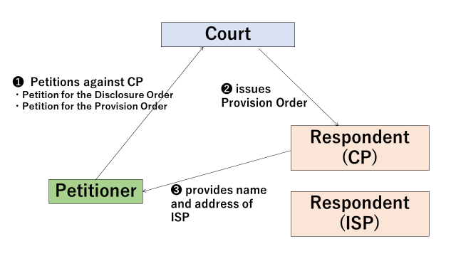

Procedure❶
A person alleging that their rights were violated by information disseminated on the internet by an anonymous sender may file the Petition for the Disclosure Order as well as the Petition for the Provision Order, as an ancillary procedure, against the CP which run the internet site on which the harmful information was uploaded.

Procedure❷
When the Petition for the Provision Order and the Disclosure Order are both filed at the same time, the Court will issue the Provision Order, if the requirements are met, prior to deciding the merits of the Petition for the Disclosure Order. Obligations imposed on the Respondent (CP) by the Provision Order consists of two steps; first, to provide the name etc. of the IPS to the Petitioner by identifying the IPS based on the information (IP address etc.) it possesses, and second, to provide IP address etc. to the IPS after receiving the notice from the Petitioner that the Petitioner has filed the Petition for the Disclosure Order against the IPS.

Procedure❸
If the Provision Order is issued by the Court, Respondent (CP) is required to immediately perform its obligation of the first step either by providing the Petitioner with the name etc. of the IPS when the Respondent can identify the name based on the information it possesses or by informing the Petitioner that it cannot identify the name of the IPS based on the information.

2.1. Petition for the Disclosure Order & the Prohibition Order against the ISP
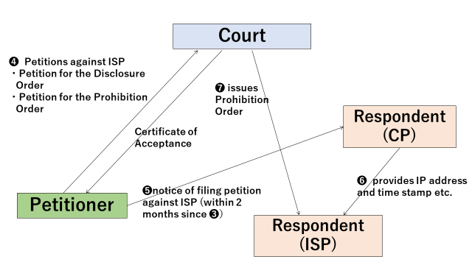

Procedure❹
The Petitioner, who receives the name etc. of the ISP from the CP, files the Petition for the Disclosure Order and, if necessary, the Petition for the Prohibition Order as an ancillary procedure against the ISP. The Prohibition Order is sought to prevent the ISP from deleting the data of sender’s information before the Disclosure Order is issued.
The Petitioner, at the time of the filing of the Petition for the Disclosure Order against the ISP, may request the Court to issue a document which certificates the acceptance of the Petition, which is used for the notice described below (Procedure❺).
Procedure❺
The Petitioner notifies the CP by attaching the document issued by the court which certifies that the Petitioner has filed the Petition for the Disclosure Order against the ISP. Unless this notice was made within 2 months since the receipt of the information of name etc. of the ISP (Procedure❸), the effect of the Provision Order is lost.
Procedure❻
Receiving the notice above from the Petitioner, the Respondent of the Provision Order (CP) provides the IPS with identification information of the sender such as IP address and time stamp that it possesses. This is the second step performance of the Order.
Procedure❼
The Court issues the Prohibition Order against the IPS who possesses the identification information of sender if requirements are met.
2.3. Proceedings on the Merits of the Petition for the Disclosure Order & the Action to Oppose the Orders
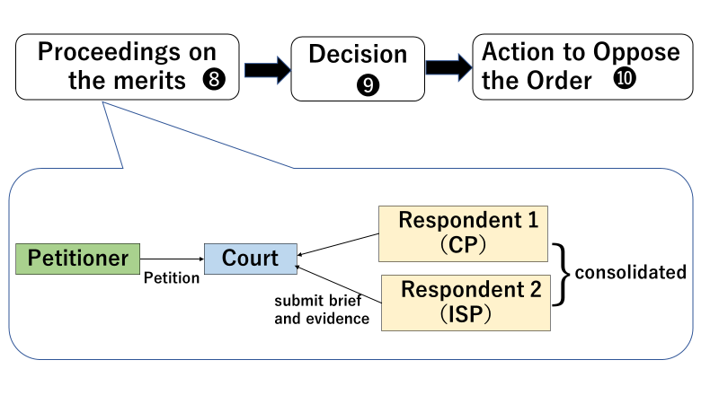
Procedure❽❾
The Court consolidates the Petitions for the Disclosure Order against the CP and the IPS. Then the Court holds the proceedings on the merits of the both Petitions in an integrated manner and makes the decision.
Procedure❿
The Petitioner dissatisfied with the Order may file the Action to Oppose the Order to the Court.

3. Filing of the Petition for the Disclosure Order

3.1. Jurisdiction (Article 9 and 10 of the Act, Article 1 of the Rule)

A . Basic Rule (in case where the respondent is a corporation)
The Tokyo District Court has jurisdiction over the Petition if either of the following place or location is within the jurisdictional district of the Court or if the court of jurisdiction is not determined pursuant to (a) through (c);
(a) location of principal office or business office of the Respondent
(b) in case that the Petition is in connection with the business conducted at the office or business of the Respondent, location of the office or business office
(c) in case that the Respondent has no office of above (a) or (b) in Japan, place of domicile of its representative or any other principal person in charge of its business

B. Concurrent Jurisdiction
If a court located in the eastern Japan has jurisdiction over the Petition pursuant to the rules mentioned in the above 3.1.A., the Petitioner may also file the Petition in the Tokyo District Court.

C. Agreed Jurisdiction
The Tokyo District Court has jurisdiction over the Petition, if the Petitioner and the Respondent so agreed.

D. Cases Related to the Intellectual Property Rights
Cases related to the intellectual property rights such as copyright infringement are assigned to the division specialized in the intellectual property rights (the 29th , 40th ,46th and 47th Civil Divisions). The 9th Division is in charge of other cases.

3.2. Documents Attached to the Petition
The following documents should be attached to the Petition;
(a) copies of the written petition (as many as number of Respondents)
(b) documentary evidences corresponding to the facts on which the Petition grounds
(c) certificate of commercial registration of the Petitioner
(d) power of attorney for the counsel
(e) memorandum to the court regarding jurisdiction (in case the Respondent is a foreign corporation and the Petitioner claims jurisdiction pursuant to Article 10, paragraph (2) of the Act)

3.3. Matters to be Written in the Petition
Matters to be written in the Petition are as follows;
(a) indication of the case
“Case of the Petition for the Order to Disclose the Identification Information of the Sender”
(b) date of filing
(c) indication of the court in which the Petition is filed
(d) name and seal of the Petitioner and his/her agent (including statutory agent and counsel)
(e) name and address of the parties and the interested party intervenor
(f) name and address of the agent
(g) postal code and telephone number (including facsimile number) of the parties, the interested party intervenor and the agent
(h) main text of the order sought by the Petitioner and reasons for the Petition
(i) facts on which the Petition grounds
(j) indication of annexed documents
(k) if the Petition is against the ISP whose name was provided to the Petitioner in accordance with the Provision Order, information of preceding Petitions

3.4. Fee for the Petition
Revenue stamp of 1,000 yen is required per petition, which shall be affixed to the written petition without applying cancelation mark.

4. Filing of the Petition for the Provision Order & the Prohibition Order

4.1. Jurisdiction
The Tokyo District Court has jurisdiction over the Petition for the Provision Order and the Petition for the Prohibition Order, if its principal petition (the Petition for the Disclosure Order) is pending before the Court (Article 15, paragraph (1), Article 16, paragraph (1) of the Act).

4.2. Documents Attached to the Petition
The Petition for the Provision Order or the Petition for the Prohibition Order does not necessarily have to be written in the same document as the Petition for the Disclosure Order. When the Petition for the Provision Order or the Petition for the Prohibition Order is written in the form separate from its principal petition, copies of the Petitions shall be submitted to the Court for sending them to the Respondent.

4.3. Matters to be Written in the Petition
Matters to be written in the Petition for the Provision Order and the Petition for the Prohibition Order are as follows;
(a) indication of the case
“Case of the Petition for the Order of Provision”
“Case of the Petition for the Order of Prohibiting Deletion”
(b) main text of the order sought by the Petitioner
(c) reasons for the Petition
(d) facts on which the Petition grounds
* When the Petition for the Provision Order or the Petition for the Prohibition Order is submitted in the form separate from its principal petition, matters to be written in the principal petition shall be written in the Petition for the Provision / Prohibition Order as well.

4.4. Fee for the Petition
Revenue stamp of 1,000 yen is required per petition, which shall be affixed to the written petition without applying cancelation mark.

5. Examples of Main Text of the Orders sought by the Petitioner

5.1. Petition for the Disclosure Order

5.1.1 Example of Main Text of the Orders sought by the Petitioner
“The Respondent shall disclose to the Petitioner each of the information on the Appendix ‘List of Identification Information of Sender.’”

5.1.2. Example of the Appendix “List of Identification Information of Sender “ (in case that the Provision Order is issued prior to the filing of the Petition for the Disclosure Order against the ISP)

“The following information of the person who connected to the URL described in the Appendix ‘List of Posted Article(s)’ by using the IP address (which is provided from ◯◯ [CP] to the Respondent [ISP] in accordance with the Provision Order issued by the ◯◯ District Court dated with December 1, 2022 [Case Number: 2022(Mo)No.…]) at the time of the date (which is also provided in accordance with the Order) around when the posted articles described in the Appendix were transmitted to the specified telecommunications facilities used by ◯◯ [CP] from the telecommunications facilities to which the IP address was assigned;
1 name
2 address”

5.2. Petition for the Provision Order

“1. The Respondent shall provide the Petitioner with matters set forth in the following (i) or (ii) in writing or by electronic or magnetic means according to the categories specified below;

Category | Matters to be Provided
(i) the case that the Respondent can identify, by the identification information of sender in its possession which is described in the Appendix ‘List of Identification Information of Sender,’ name and address of other provider/providers of disclosure-related services (excluding the person found to be the sender; the same applies hereinafter) pertaining to the information on the Appendix ‘List of Posted Article’ (hereinafter referred to as ‘information such as the name of other provider/providers of disclosure-related services’) | information such as the name of other provider/providers of disclosure-related services
(ii) the case that the Respondent does not possess the identification information of sender described in the number ◯ to □ of the Appendix ‘List of Identification Information of Sender’ or the case that the Respondent cannot identify the matter set forth in the above (i) by the identification information of sender that it possesses. | statement to that effect

2. When the Respondent is notified, in writing or by electronic or magnetic means, by the Petitioner who received information such as name of other provider/providers of disclosure-related services in accordance with the Order of the preceding paragraph, that the Petitioner has filed the Petition for the Disclosure Order pertaining to the information on the Appendix ‘List of Posted Article,’ the Respondent shall provide the provider/providers, in writing or by electronic or magnetic means, with the identification information of sender described in the number ◯ through □ of the Appendix ‘List of Identification Information of Sender’ that it possesses.”

5.3. Petition for the Prohibition Order

“The Respondent shall not delete the identification information of sender on the Appendix ‘List of Identification Information of Sender’ until the case (the ◯◯ District Court, Petition for Disclosure Order, 2022 (Hatsu-chi) ……) is completed by the order (except for the order to dismiss the petition as unlawful) or, in case that the action to oppose the Order is filed, the action is completed.”

